Topics for the StudentDigitalFest

- Develop a stand-alone MAASP (MAASP maximum allowable annular surface pressure) calculator based on the ISO/TS 16530-2 and API 90-2 guidelines.
The MAASP calculator will be used to ease the manual calculation done today and shall include the following input variables:
- Tubing size, grade and weight
- Tubing wear based on either
  - Caliper Result
  - Simple de-rating based on API-90-2
- Casing size, size , grade and weight
- Casing wear calculations based on
  - Caliper Result
  - Simple de-rating based on API-90-2
- Fluid densities in the different annuli
- Top of cement outside the different casing(s)
- Simplified MAASP output from the different load conditions
  - Collapse rating of the completion / well equipment
  - Burst calculation of the well equipment

Objective (for what?)
To standardize the MAASP calculation to ensure repeatability and QA of the calculation and to define the operation envelope of the wells

Information to be provided (which docs/info?)
ISO standard/ KPO Well Integrity Management System (WIMS). API material strength tables

Output (what is expected?)
A simplified and easy to use calculator with standardized input vairables and a clear output that will be used to define the operating envelope is a common way

A – Annulus calculation points
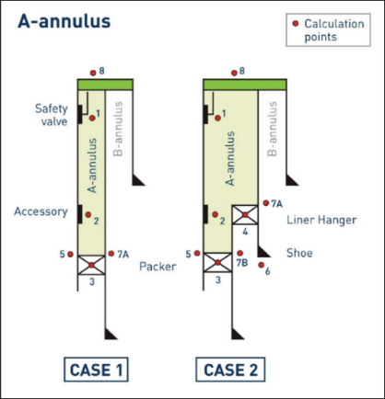

B – Annulus calculation points

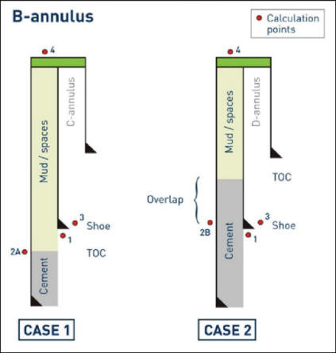
C – Annulus calculation points

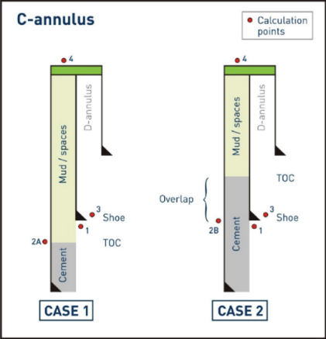

- Digital solutions in improving the control on vehicles field access in gas hazardous areas

Objective (for what?)
Deny access to vehicle not working for company Business, Preventing unauthorized entry to gas hazardous areas

Information to be provided (which docs/info?)
Safety/Security issues

Output (what is expected?)
Separate system from existing EACS – Electronic Access Card System, No delays during vehicle checks. CCTV camera should recognize vehicle license plate at the same time as guard will check driver and passengers cards, Less complicated solution without access levels and other EACS related technicalities

Layout for reference
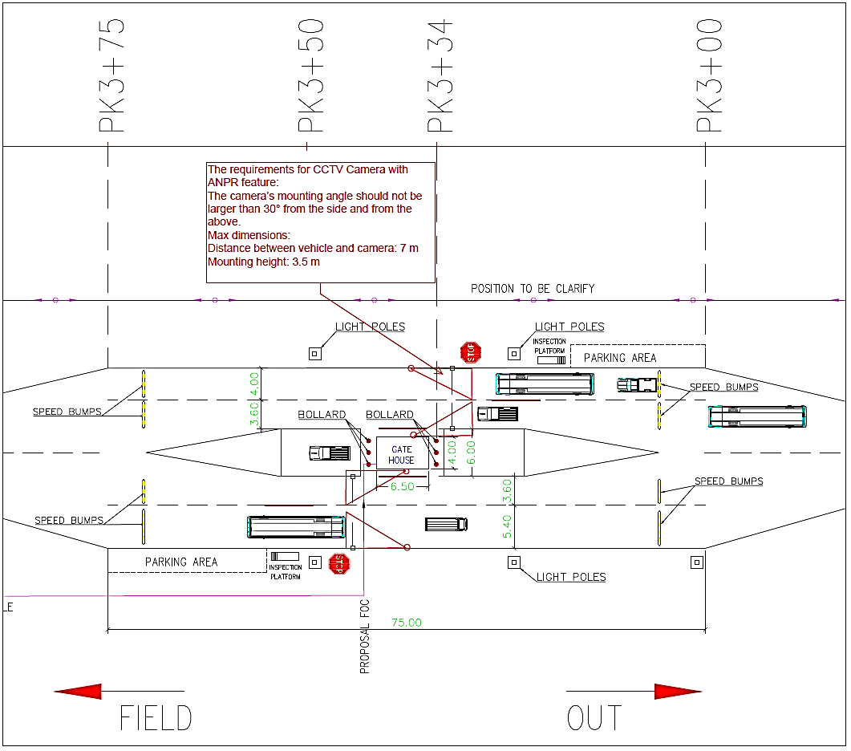

3. Implementation opportunities of an integrated electronic system for registration of potential suppliers in the company database through the Digitalization.

Objective (for what?)
Improve efficiency and eliminate unnecessary paperwork

Quickly find potential Suppliers

Improve marketing capabilities, while allowing participants to sign up when and where it is most convenient for them from any Internet-enabled computer

Save time for managing the documents (questionnaire etc.) where is most convenient without having to print, manually fill out and send paper forms through the system

Information to be provided (which docs/info?)
To be clarified

Output (what is expected?)
Online to obtain all the required information of a Suppliers

Suppliers will be responsible for correctness of information and other entities /
Save time and human resources on registration and updating the Suppliers’ data on the current company system.

